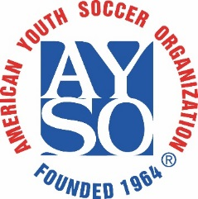 | Sponsored by AYSO Region 24 Downey, CA  22nd Annual KICKOFF CLASSIC  Guest Player Form – AYSO players only | 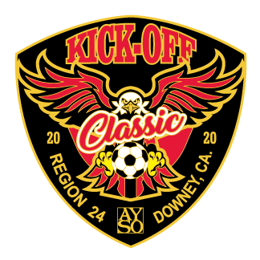

Borrowing Team Information: |  |  |  |  |  |  |  |  | Roster Date:
Region: |  |  |  |  |  | Team Name:

Coach Name:
Age Division: |  | 8U | 10U |  |  |  | 12U |  |  | 14U |  |  | 16U |  |  | 19U |  | Boys |  |  |  | Girls |  | Coed

Kickoff Classic Tournament rules allow teams to bring up to 3 “Guest Players” when they are unable to recruit sufficient players from their own Region. These Guest Players must be properly registered AYSO players who were registered and played in their home Region in the 2019 primary program.

(List In Order By Uniform Shirt No.)
Shirt  # | Region  # | Player ID # | Player’s Name  Last, First (please print) | Age | Date of Birth | Telephone  Including Area Code

By my signature below, I certify that all players on this roster are valid registered players in my region and are approved to join the above team and participate in this tournament:
Guest Player(s) Regional Commissioner:
 |  | Print Name Signature (Blue or Red Ink)
E-mail: |  |  |  | Best Phone:
By my signature below, I approve that these |  |  |  |  | (number of players) guest players are
approved to join the above team and participate in this tournament:

Host Team Regional Commissioner:

